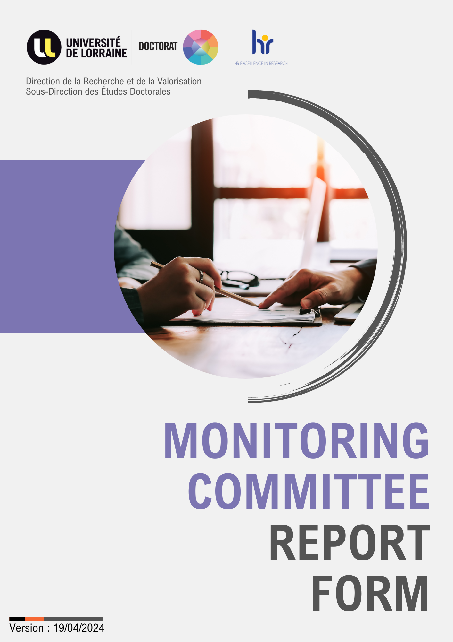

Research and Promotion Department
Doctoral Studies Division

GUIDELINES

Reminder: Monitoring must ensure that the PhD student has a yearly meeting with teacher-researchers or researchers who are not involved in his/her thesis work. It enables external assessment to make sure that steps in development of thesis work are consistent and that appropriate progress is being made.

The Individual Monitoring Committee (IMC) focuses in particular on the PhD student’s general wellbeing and work environment.
It is essential that confidentiality is respected. However, the PhD student may specifically ask members of the IMC to bring up any problems in the presence of a third party (Laboratory Director, Doctoral School Director, etc.).

The IMC helps resolve any conflicts arising between the PhD student and his/her environment. In this respect, a distinction must be made between serious problems and minor complaints. Minor conflicts are a regular occurrence in any work environment. Only problems that might hinder the thesis’ progress or affect the PhD student’s future career should be discussed.

Possible questions to ask during the annual assessment (suggestions to adapt as required):

- Do you receive enough advice and help from your Supervisor and laboratory colleagues to ensure that your research advances at a reasonable pace?
- How often do you have work meetings with your Research Director? Is the pace of work appropriate? :
- If your thesis is jointly supervised, are your Thesis Supervisors both present at meetings? Do they always agree with each other? If not, what impact does it have on the progress of your work?
- Do you feel that your doctoral project is making good progress? If not, have you analyzed the reasons why?
- Do they stop you making any progress at all? Have you discussed them with your Supervisor(s)?
- Are there any professional conflicts between you and your Supervisor(s) or between you and your colleagues? (These may include authorship problems, requests for involvement in side projects or projects that are marginal to the thesis, etc.)
- Are you encouraged to present the results of your thesis work? If yes, in what form?
- Do you feel able to discuss problems freely with your Supervisor?
- Does your Supervisor advise you on what courses to follow? • ….

Student (Name / First Name)

Thesis subject

Thesis supervisor (Name / First Name)

Thesis Co-supervisor (Name / First Name)

Name of the thematic team and of the Research Unit

Funding method:

Cotutelle (if applicable):
Partner University

Representative

Thesis Co-supervisor

Date of first registration (month/year) ………. / ……….

Date(s) of previous assessment(s) ……... /………. / ……….

Presentation of research work (to be filled out by the PhD student)
Non-exhaustive help to the writing of the annual report on the thesis progress

Presentation of the thesis objectives

What advances have been made on the project?

What difficulties/obstacles have you encountered and what have you tried to do to overcome them?

Are the laboratory’s equipment, work environment and hosting conditions compatible with progress in your work?

Need to refocus/redefine the evolution of the thesis work

Scientific valorization of the thesis: Specify any scientific production connected with the subject of the thesis (communication during an internal/external seminar, at a colloquium with/without proceedings, conferences, workshops, writing of articles, etc.

Other details

PhD Student’s signature:

To be filled out by the CSI members after they met the PhD student
Non-exhaustive help to the writing of the CSI report

Relevance of the written report provided before the meeting, clarity of the oral presentation by the PhD student, mastery of concepts, biblio, state of the art....

Assessment of the progress and quality of the research work (if applicable, you may want to mention the impact of collaborations such as CIFRE or Cotutelle)

Evaluation of research prospects, realism of the provisional planning, especially if a defence is planned within the year (if applicable, as of the second CSI).

Specify the professional project, if it has already been defined

Opinion on the trainings carried out/planned/intended and skills acquired or in the process of being acquired, relating to the PhD student's professional project

Commitment and motivation of the PhD student.

Involvement of the PhD student in UL structures? In the organizing of research-focused events? Teaching or firm consulting?

Environnent and thesis work conditions

Meetings rhythm between the PhD student and his/her supervisor(s)

Possible relational difficulties / conflict of interest between the PhD student and his/her supervisor(s)

Remarks:

Suggestions/ Recommendations

The Committee’s opinion on a possible re-enrolment (if applicable):
Favorable Reservations Unfavorable

Arguments (if appropriate) :

Date: ………. /………. / ………

Committee member 1 Committee member 2

………………………. ……………………..…
For HNFB doctoral school :
To be filled by the thesis supervisor(s) and the CSI members following their meeting

Meeting date: …./….. /…….

Possible observations/comments to be specified to the doctoral school :

Committee member 1 Committee member 2

Name and signature Name and signature

…………………….. ……………………..

Thesis supervisor Thesis co-supervisor Thesis co-supervisor

Name and signature Name and signature Name and signature

…………………….. …………………….. ……………………………

